Assignment 1

The Scott Expedition – Antarctica 2014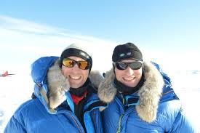

In 2013-14, Ben and his teammate Tarka L’Herpiniere retraced the route of Captain Scott’s Terra Nova expedition. Walking from Ross Island, on the Antarctic coast, to the South Pole and back, while hauling sleds with everything they needed to survive 105 days on the coldest, windiest, highest and driest continent on Earth.

The Transarctic Expedition – North Pole 2004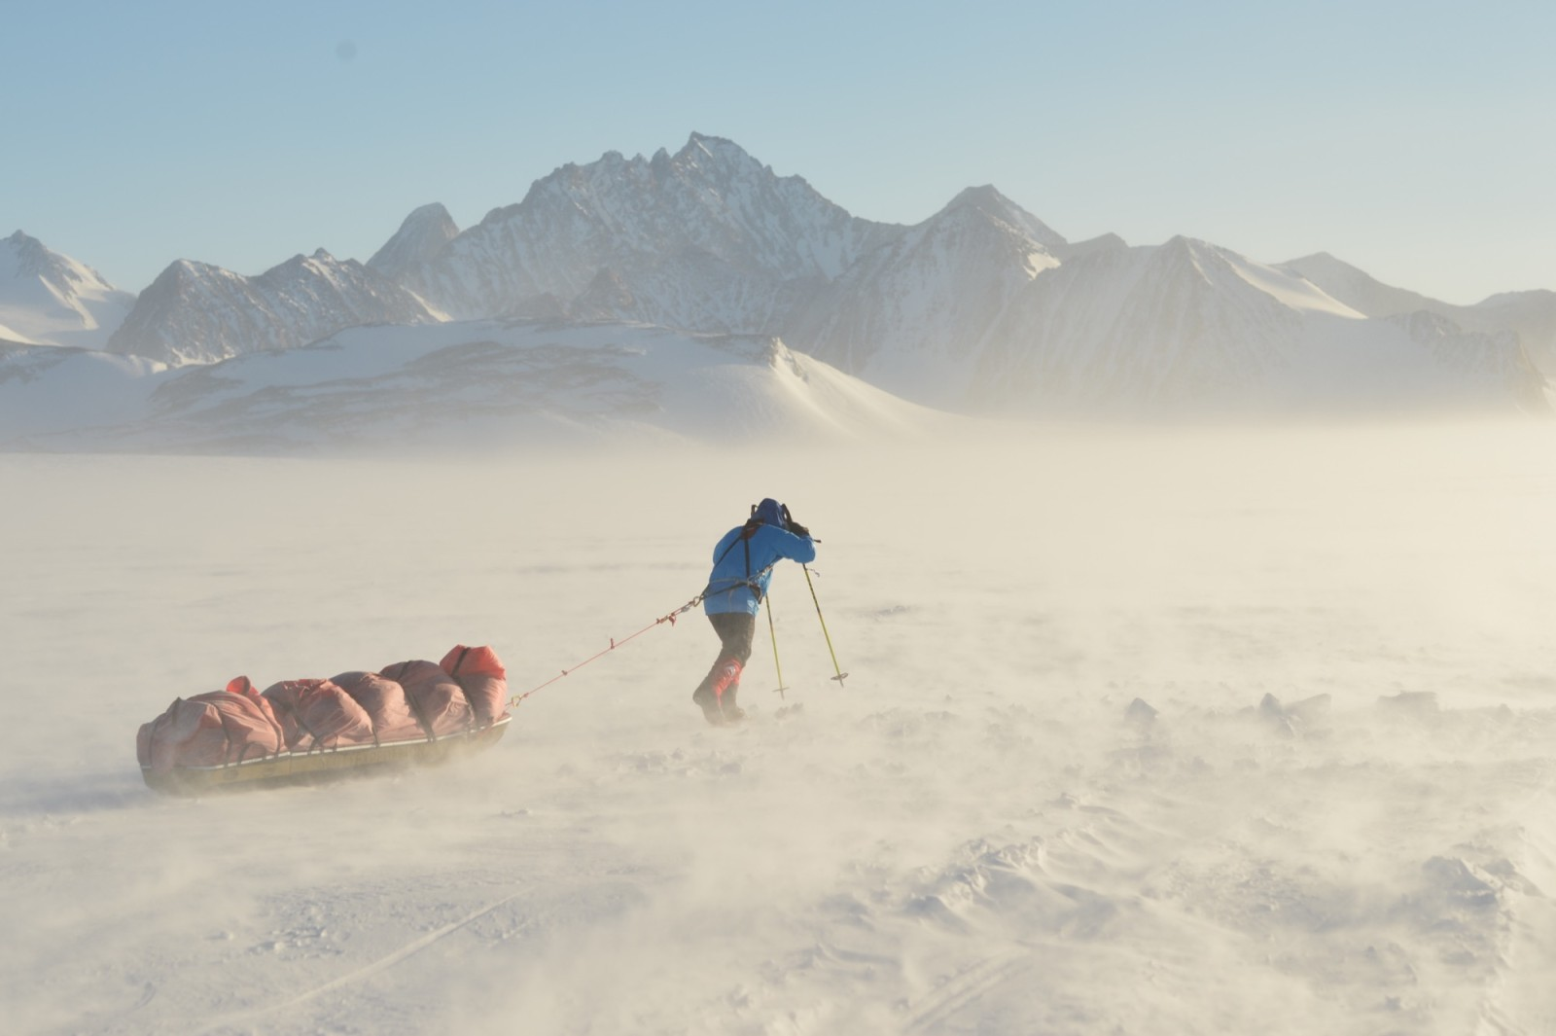

In 2004, Ben set out to ski solo from Russia to Canada across the frozen Arctic Ocean. He successfully reached the North Pole but on the second leg of the trek – to Canada – the sea ice began to break up and Ben was forced to call for a pick up. This journey has never been completed